Ticket Id 41843
Subject: Site Map: a few edits needed

Entered by: Isabelle
Date: 1/24/07
Addressed to: Wendy

Ticket Description:

1. Space between Announcements section and the next needs to be reduced to match other sections

2. About This Dataverse link should not appear on Dataverse Network Site Map

3. HELP should be its own section - I suggest HELP as an indented title (no link, black characters), and below a hyperlink with a different word, such as Documentation (which we can change later if we want to)

4. Most Recent link should not be there if there are no Most Recent studies at the network level

5. I wonder if we could have a More link that would take users to dataverses or collections not showing on the site map.

6. The site map looks different whether in IE or Firefox.

Screen capture (one is in IE, the other in Firefox, but it’s the same Dataverse Network)

Go to next page..

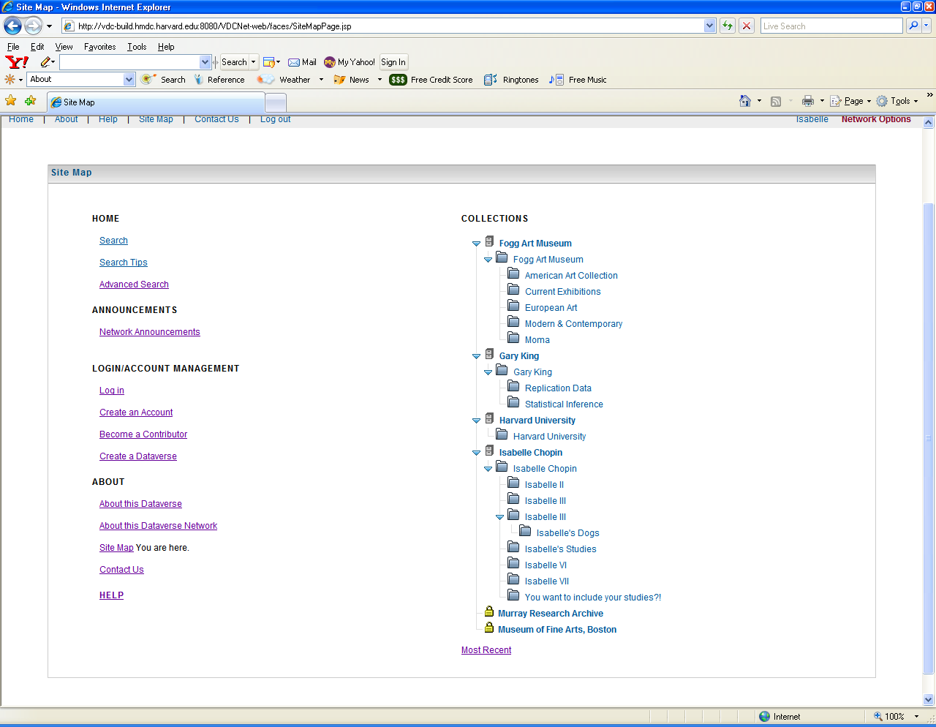

Go to next page..
